Streamwood VFW Post 5151’s
OPERATION AIRLIFT
Gift packs for soldiers serving overseas
List of mailable items
Bring your donation from the list below to the
“2023 Summer Celebration Car, Truck,
and Cycle Show”
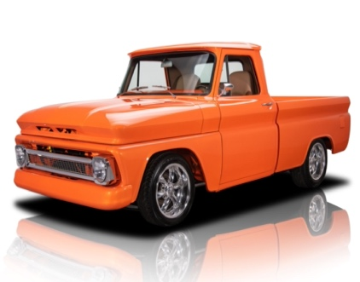
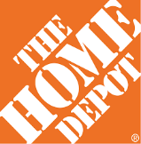
PERSONAL HYGIENE ITEMS
High quality razors, foot powder, Chapstick, ibuprofen, Mucinex, dental floss, shampoo, conditioner, hand cream, Q-tips, tissues, stick deodorant, toothbrushes, toothpaste, bar soap, gel shaving cream

FOOD AND SNACKS
Protein bars, granola bars, nuts (roasted peanuts, cashews, almonds, etc.) sunflower seeds, fruit snacks, instant soup mixes, ramen noodles, cookies, beef jerky, peanut butter (no glass), peanut butter & cheese crackers, canned fruit, chips-small bags, microwave popcorn, Slim Jims, cans of tuna or chicken, Checks mix, Cheeze-its, Goldfish.

CANDY AND GUM
Brand name chewing gum, lifesaver rolls, hard candy, Swedish fish, skittles, individually wrapped licorice, airheads.

POCKET SIZE POWERED DRINKS
Propel powder drinks, protein powder drinks, hot chocolate packets, instant coffee, lemonade, Emergen-C.

MISC
Ziploc bags (quart or gallon), hand sanitizer, stationary, envelopes, pens, pencils, dice, travel-size games, books, socks.
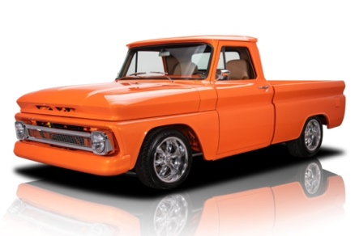
Saturday, July 22nd, 2023
10:30 am to 3:30 pm
Schaumburg Home Depot
100 Barrington Road
Schaumburg, IL 60194

RAIN DATE – July 29th

